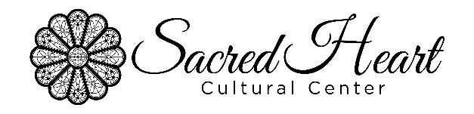
CALL FOR STUDENT ARTIST SUBMISSIONS
SACRED HEART ART HALL, OCTOBER 2024 SHOW

The Sacred Heart Art Hall is a non-profit gallery dedicated to exhibiting two-dimensional works by local and regional artists. The inaugural Augusta Through Fresh Eyes Student Art Show will run from October 8 – 25 with an opening reception on the 8th. This is an opportunity for High School students (13-18years old) and college students to experience the process of entering and exhibiting work in a local art show. Additionally, art will be available for purchase and sold at a 70/30% commission fee between the artist and Sacred Heart.

Students can submit in ONE of three categories: Youth, 13-15 years old, Young Adult, 16-18 years old, and College (any current college student). Submissions will be reviewed and chosen by a committee with first, second, and third place awards in each category. Applicants must be current high school or college students in the CSRA. Up to two submissions per applicant permitted.

Theme
The theme of the show is Augusta Through Fresh Eyes; art should reflect Augusta and the local CSRA from the artist’s perspective. No nudity, obscenity, or profanity allowed.

Artwork Information
• Artwork must be two-dimensional, framed or gallery wrapped, wired, and ready to be hung. No work should be less than 8” in width and no larger than 24” x 26”.
• Work previously exhibited at Sacred Heart Cultural Center is not allowed.
• All work must be for sale; artist will determine price.

Selection and Pick Process
Once notified of selection in show, students will have until 5 pm Friday, October 4 to deliver the physical artwork to Sacred Heart (see address below). After the exhibition, all artwork must be picked up by 5 pm Friday, November 1. Any work left past the pickup date without communication about delay will be considered donated.

To be considered, please complete the form below and send attachments to Zachary Alvarez at zachary@sacredheartaugusta.org by Friday, September 6, 2024. Selection notifications will be sent via email by September 20.

If you have additional questions or comments, please contact Zachary Alvarez by email or phone 706-826-4700.

Sacred Heart Cultural Center
1301 Greene St
Augusta, GA, 30909
706-826-4700
ARTIST INFORMATON
Artist Name:____________________________________________________________
Artist Address:__________________________________________________________
Artist City:_______________________ State:_____________________ Zip:_________
Artist Phone Number: __________________ Email: ____________________________
Artist Primary Medium: ___________________________________________________
School/University:_______________________________________________________
Artist Social Media/website: _______________________________________________
ATTACHMENTS
- High resolution images of work to be shown (1-2 pieces)
- Short Biography of Artist (3-5 sentences)

Sacred Heart Cultural Center
1301 Greene St
Augusta, GA, 30909
706-826-4700

